Rolling correlation: EURUSD and NZDUSD
Method 05 / daily log returns / windows 20, 60, 100 / Secondary tier

Study setup
Logical pair: EURUSD , NZDUSD
Broker symbols: EURUSD_i , NZDUSD_i
Tier: Secondary tier (secondary)
Snapshot: 2026-11-03_majors_alpari_D1
Timeframe: D1
Matched return window: 1999-01-05 to 2026-11-02 (UTC bar dates)
Matched return count (rows before rolling): 7186
Dropped unfinished last bar dated 2026-11-03 UTC after a tick-volume check against the prior complete day.
Rolling windows W: 20, 60, 100 trading days
Live-shaped n for each score: n = W (not the full history length)
Complete matched rows (CSV): EURUSD-NZDUSD_Rolling_D1.csv
Complete matched rows (HTML): EURUSD-NZDUSD_Rolling_D1_data.html

Method carried forward
Rolling Pearson r is computed on matched daily log returns of close, ln(close_t / close_t-1), in the broker quote direction. Quotes are not inverted. For each day t with a full window, r_W uses the last W matched return pairs ending at t. That live-shaped sample size is W (20, 60, or 100), not the full multi-year history. The first W-1 days have no score. r is symmetric under swap of the two symbols. A high |r| in one window does not prove cause, lead-lag, or a trading signal. Short windows are noisier; long windows are slower to reflect a break.
How to read a live day: after both daily candles close, the newest r_20 uses the last 20 matched log returns, r_60 the last 60, and r_100 the last 100. Compare those three to each other and to the full-sample baseline below. A break is when the short window moves far from the baseline or flips sign while the baseline was meaningful.

Full-sample Pearson baseline (method 01 v001)
Copied full-sample Pearson r for EURUSD-NZDUSD: 0.549808. This is a historical average link, not the live state.

Rolling results
W | latest_r | mean | median | min | max | std | pct_|r|>=0.4 | pct_|r|>=0.7 | n_roll
20 | 0.477766 | 0.532605 | 0.580597 | -0.514627 | 0.942627 | 0.240765 | 73.59 | 29.34 | 7167
60 | 0.685647 | 0.537146 | 0.572218 | -0.157124 | 0.85914 | 0.185169 | 77.73 | 21.23 | 7127
100 | 0.717512 | 0.540003 | 0.571854 | -0.03843 | 0.827833 | 0.164785 | 78.92 | 16.44 | 7087
n_roll is the number of days that had a complete window. pct_|r|>=0.4 and pct_|r|>=0.7 are the share of those days where the absolute rolling correlation cleared the threshold.

Conclusion
For EURUSD and NZDUSD, full-sample Pearson baseline r=0.5498. Latest rolling scores: r_20=0.4778, r_60=0.6856, r_100=0.7175. Stability: moderate window-to-window variation. Agreement with baseline: r_20=0.478 near baseline; r_60=0.686 near baseline; r_100=0.718 near baseline. Tier line: secondary — keep on a lower-priority board next to the watchlist. This is a monitoring summary, not a trade signal.

What to look at in this file next time
1) Latest r_20 vs r_60 vs r_100 in the results table. 2) Whether short-window latest has the same sign as the baseline. 3) The rolling chart for stretches where |r| collapsed. 4) The CSV if you need a different chart later.

Charts
Rolling Pearson r (20 / 60 / 100)
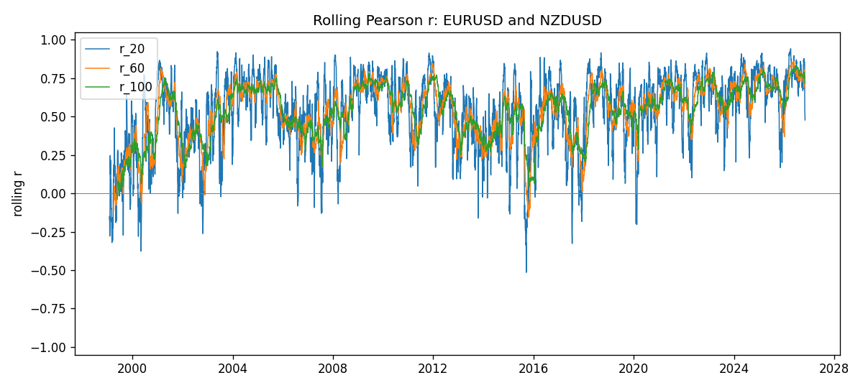
Daily closes

Daily log returns
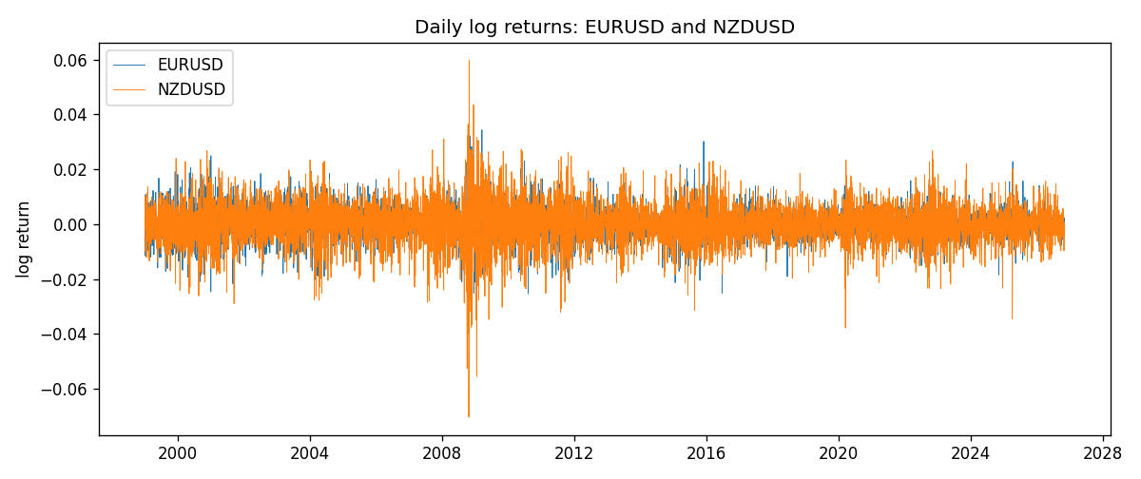

Data report
Every matched row with r_20, r_60, and r_100 is in the sibling CSV and HTML. This Word section holds column summaries and the first and last 15 rows of the rolling table.
Columns: time, EURUSD_close, NZDUSD_close, EURUSD_tick_volume, NZDUSD_tick_volume, EURUSD_log_return, NZDUSD_log_return, r_20, r_60, r_100
Column summaries
column | count | mean | std | min | 25% | 50% | 75% | max
EURUSD_close | 7186 | 1.1814 | 0.150827 | 0.8267 | 1.08604 | 1.16602 | 1.29397 | 1.5997
NZDUSD_close | 7186 | 0.656492 | 0.108195 | 0.3907 | 0.59159 | 0.66842 | 0.725015 | 0.8822
EURUSD_tick_volume | 7186 | 103205 | 173535 | 218 | 9413.25 | 52774.5 | 99579.8 | 1.47163e+06
NZDUSD_tick_volume | 7186 | 68709 | 123134 | 16 | 5585.5 | 33893.5 | 58510.5 | 1.12768e+06
EURUSD_log_return | 7186 | -4.99e-06 | 0.00579654 | -0.0312382 | -0.00323792 | 0 | 0.00325328 | 0.0343318
NZDUSD_log_return | 7186 | 9.3e-06 | 0.0076423 | -0.0702743 | -0.00425367 | 0.00022883 | 0.00457975 | 0.0596684
r_20 | 7167 | 0.532605 | 0.240765 | -0.514627 | 0.386504 | 0.580597 | 0.722287 | 0.942627
r_60 | 7127 | 0.537146 | 0.185169 | -0.157124 | 0.42132 | 0.572218 | 0.684991 | 0.85914
r_100 | 7087 | 0.540003 | 0.164785 | -0.0384304 | 0.430303 | 0.571854 | 0.677519 | 0.827833
First 15 matched rows
time | EURUSD_close | NZDUSD_close | EURUSD_log_return | NZDUSD_log_return | r_20 | r_60 | r_100
1999-01-05 | 1.1758 | 0.5372 | -0.00483605 | -0.00185977
1999-01-06 | 1.1623 | 0.5383 | -0.011548 | 0.00204556
1999-01-07 | 1.1712 | 0.5417 | 0.00762806 | 0.00629632
1999-01-08 | 1.1585 | 0.5414 | -0.0109028 | -0.000553965
1999-01-11 | 1.1503 | 0.547 | -0.00710329 | 0.0102904
1999-01-12 | 1.1555 | 0.5441 | 0.00451037 | -0.00531575
1999-01-13 | 1.1681 | 0.5387 | 0.0108453 | -0.00997422
1999-01-14 | 1.1681 | 0.5386 | 0 | -0.000185649
1999-01-15 | 1.1563 | 0.5382 | -0.0101532 | -0.000742942
1999-01-18 | 1.1605 | 0.5372 | 0.00362569 | -0.00185977
1999-01-19 | 1.1603 | 0.5382 | -0.000172354 | 0.00185977
1999-01-20 | 1.1566 | 0.5404 | -0.00319393 | 0.00407937
1999-01-21 | 1.1601 | 0.5426 | 0.00302154 | 0.00406279
1999-01-22 | 1.1587 | 0.5361 | -0.00120752 | -0.0120517
1999-01-25 | 1.1552 | 0.5342 | -0.0030252 | -0.00355041
Last 15 matched rows
time | EURUSD_close | NZDUSD_close | EURUSD_log_return | NZDUSD_log_return | r_20 | r_60 | r_100
2026-10-13 | 1.11965 | 0.56127 | 0.0037403 | 0.00473262 | 0.871516 | 0.781102 | 0.757043
2026-10-14 | 1.11545 | 0.55918 | -0.00375823 | -0.00373065 | 0.854008 | 0.787553 | 0.778167
2026-10-15 | 1.12172 | 0.56185 | 0.00560531 | 0.00476349 | 0.869972 | 0.790555 | 0.77906
2026-10-16 | 1.12371 | 0.56509 | 0.00177249 | 0.0057501 | 0.878296 | 0.79527 | 0.787183
2026-10-19 | 1.12086 | 0.56616 | -0.00253946 | 0.00189171 | 0.852564 | 0.785158 | 0.784109
2026-10-20 | 1.12354 | 0.56827 | 0.00238817 | 0.00371993 | 0.873947 | 0.786579 | 0.786022
2026-10-21 | 1.12318 | 0.57003 | -0.000320467 | 0.00309233 | 0.864255 | 0.805867 | 0.789391
2026-10-22 | 1.12139 | 0.56815 | -0.00159496 | -0.00330352 | 0.868625 | 0.799401 | 0.789345
2026-10-23 | 1.11989 | 0.56991 | -0.00133852 | 0.00309299 | 0.853398 | 0.788343 | 0.770007
2026-10-26 | 1.11735 | 0.56826 | -0.00227066 | -0.00289939 | 0.854881 | 0.787415 | 0.770431
2026-10-27 | 1.11272 | 0.56811 | -0.00415234 | -0.000263999 | 0.849113 | 0.77294 | 0.763986
2026-10-28 | 1.1152 | 0.56261 | 0.00222629 | -0.00972839 | 0.594041 | 0.709979 | 0.728776
2026-10-29 | 1.11772 | 0.56296 | 0.00225714 | 0.000621907 | 0.537241 | 0.707054 | 0.721984
2026-10-30 | 1.11644 | 0.56307 | -0.00114584 | 0.000195377 | 0.533023 | 0.698569 | 0.721322
2026-11-02 | 1.11881 | 0.56161 | 0.00212057 | -0.0025963 | 0.477766 | 0.685647 | 0.717512

